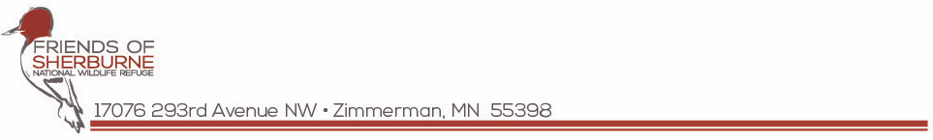

NEWS RELEASE Contact: Myrna Krueger
Friends of Sherburne National Wildlife Refuge
FriendsofSherburne@gmail.com

Oct 12, 2023 DRAFT Friends text is new. Sandhills staging text is from 2022.

Sandhill Cranes Staging at Sherburne National Wildlife Refuge

Over X,X00 sandhill cranes are staging at the refuge, taking a rest along their southerly migration route. More cranes are arriving daily, and from mid-October to early November the refuge hosts large numbers of these prehistoric birds as they roost overnight in refuge wetlands and then fly out to local croplands to forage during the day. The peak number of cranes observed in one day typically occurs during the last week of October and can exceed XX,000 birds!

If you would like to visit the refuge to see the cranes, the best time is dawn or dusk when the cranes are leaving or returning to their roost sites. If you’re not an early riser, during the day you can scout for groups of cranes in recently harvested farm fields by driving the county roads north and west of the refuge. A sandhill crane viewing brochure with a map and information about the best crane viewing areas is available at the Friends of Sherburne website, ExploreSherburne.org. Like in past years, the County Road 70 parking lot on the refuge’s northern boundary yields large groups flying overhead to nearby farmlands at dawn and dusk.

Up for an adventure? You can walk ¾ mile from the A6 parking lot to Durgin Pool, where you’ll be treated to seeing sandhill cranes, along with ducks, swans and grebes. Find the numbered parking lots on the refuge’s Hunting Brochure – note that blaze orange or blaze pink is recommended for this viewing option.

Want to learn more about Minnesota’s tallest bird? Watch recorded live programs about the behaviors and history of the staging population or on the life history of cranes on the Friends of Sherburne Facebook page, facebook.com/sherburnerefugefans/videos/ (Sandhills at Sherburne: A Fall Phenomenon and Sandhills at Sherburne: From Colt to Crane).

Friends of Sherburne NWR Host Virtual Sandhill Celebration Fundraiser

Join the Friends of Sherburne for a virtual celebration of our favorite bird – the Sandhill Crane.
As the cranes stage at the refuge during their migration south, the Friends of Sherburne are hosting an online fundraiser, a virtual “gala dinner” where the offerings are snail hors d’oeuvres, grasshopper gratinée and cattail casserole. When you “buy” the cranes a meal by donating $20 or more, you’ll be showing your support for the cranes, a future amphitheater and nature education at the refuge. Now through October 31, all donations of $20 or more will receive a free commemorative sandhill crane sticker perfect for a water bottle or laptop. Check it out at Give.classy.org/SandhillCelebration23.

Sandhill Stations Providing Crane Info to Refuge Visitors

This year, the refuge and the Friends of Sherburne National Wildlife Refuge are hosting “Sandhill Stations” to help orient visitors about the best places to see the cranes at the refuge while they are staging. You’ll be provided with directions and maps, plus have the ability to ask any questions about cranes. Sandhill Stations will be held at the Bur Oak Welcome Station (first stop) on the Prairie’s Edge Wildlife Drive on Saturdays, October 21 and 28, and Sundays, October 22 and 29, from 3:00 pm to 5:00 pm.

Fall Shopping at Eagle’s Nest Nature Store

For field guides, refuge branded apparel and nature-oriented gifts – including cozy knit hats and hooded sweatshirts -- visit the Friends of Sherburne Eagle’s Nest Nature Store at the Oak Savanna Learning Center, open Thursdays and Saturdays from 10 am to 2 pm, 16797 289th Ave NW, Zimmerman. The nature store is available online at SherburneEaglesNestStore.com. Proceeds from the store benefit the refuge.

Photo: Mary “Karlie” Carlson
In 2022, nearly more than 29,000 cranes were counted in one day during a refuge count. Plan your visit to see these amazing birds and celebrate their annual autumn visit to our area!

-end-

Friends of Sherburne National Wildlife Refuge is a 501(c)(3) nonprofit organization that nurtures an appreciation for and the conservation of Sherburne National Wildlife Refuge through education, volunteerism and philanthropy.

